

**Problem 1: Under Pressure**

**Question:** What is the force applied by a laser pointer on the screen when it is used to comment a lecture slide?

**Variables:**

* P – laser power ()
* – monochromatic laser wavelength (which can be assumed so due to its narrow range 640-660nm), – laser frequency
* – number of photons emitted by the laser in time
* – restitution coefficient of the screen in the second case
* Energy of a photon
* – angle of incidence between the laser and the screen
* – force exerted by the wall on the photons
* – force exerted by the laser on the screen, which we aim to estimate
* and – initial and final momenta of the photons
* and– initial and final unit vectors along the paths of the ray

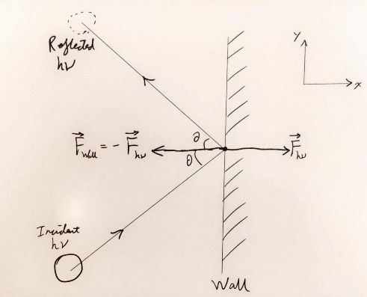For solving this problem, we employ the intermediate model for light. Massless photons with momentum hit the screen at an incidence angle and bounce back. The first level of analysis assumes the screen to be a perfect mirror () and the photons undergo elastic collisions, while in the second one, the screen has a restitution coefficient , due to phenomena like absorption or transmission. We consider the screen to be in the YZ plane, with the unit vector normal to the plane.

Figure 1: Elastic collision of a photon with the screen (wall) at angle with the normal. The photon imparts a force to the screen (wall) while the wall a force the photon.

**Elastic collisions**

The unit vectors corresponding to the directions of the photons before and after the collision are:

The initial and final momenta of the incoming photons are:

and

And the momentum difference

The power of the beam is , hence the momentum difference writes

From Newton’s second law, the force exerted by the wall on the photons is:

From Newton’s thirds law, the force exerted by the beam on the screen is :

Substituting , we obtain

At normal incidence screen () , while for a beam tangent to the screen () .

**Inelastic collisions**

The initial momentum of the photons remains the same, while the momentum after the collisions is:

The momentum difference before and after the collisions is:

and the force on the screen

As , . At normal incidence .

**Validation**

We validate the above theory by calculating the plausibility of the comet tail.

We first agree that the radiation pressure of the star can act on the dust particles dropped by the comet, and this effect produces tails of comets. So we validate the formula as follows, we can collect public astrophotography photos of different comets and their position data relative to the stars. According to the direction of the comet tail, we can get a relationship between the magnitude of the star's gravitational force and the force of light applied on the dust particles.

In the following, we will calculate the total power of the solar. We use the solar reference spectrum in April 2008 as recorded by the Solar instrument on the International Space Station. We take the corresponding wavelength of maximum of solar spectrum irradiance (SSI) as . We treat the solar as a perfect Blackbody. By the Wien's displacement law and constant of proportionality as , we have the temperature of the solar:



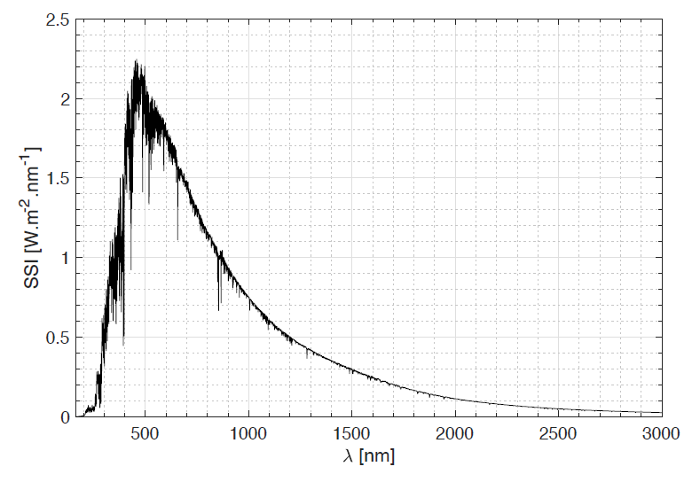

Solar spectrum in April 2008 as recorded by the ISS

We use the Stefan-Boltzmann law for solar and set the radius of the solar as , with the Stefan-Boltzmann constant , then we have the irradiance and total power of the solar is:





In the following, we will calculate the star's gravitational force and the force of light applied on the dust particles dropped from C/2022 E3 (ZTF) from approximately January 23rd to January 24th, 2023. According to the data on theskylive, the distance between the comet and the sun on that day is about Million Km.

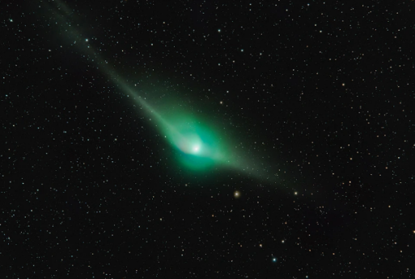

Dominic Reardon captured this image of Comet C/2022 E3 ZTF on 25/26 January 2023 from Arnside, Cumbria, UK

Consider a 0.05g electrically neutral dust particle of the cross-sectional area of .The gravitational force of the solar with gravitational constant  applied on it is:



For the formula above, the force of sunlight applied on it is:



And:



We can find that the force of light acting on dust particles (here is a 0.05g particle with normal cross-sectional area) cannot be ignored compared with the gravitational force. This can explain why the trajectory of the comet tail (the tail of electrically neutral dusts) is different from the direction of the comet. We also observe by the graph that the former direction point away more from the solar than the opposite direction of the comet. Therefore, we in some extent validate the formula above. With more data, we may deduce more precise conclusion.

**Conclusion**

In both cases the modulus of was found to be of the order of (), . To give a comparison on the effect and order of this force, consider the E. Coli bacterium which is approximately of mass . This force would thus accelerate E. Coli bacterium to an order of . This magnitude of force has negligible effect on the structure of the wall. Indeed, consider the case that this force moves an atom in the wall by an order of 1 Angstrom which is . We chose 1 Angstrom as it represents approximately the order of distance between successive carbon molecules. This gives a work done of order . On the other hand, to break a carbon-carbon single bond, it requires energies of the order at least . As a result, the energy is not enough to deform the structure of the wall.